ESTATEIQ AI – INTELLIGENT REAL ESTATE PRICE EXPLORATION TOOL

A Project Report Submitted in
the partial fulfillment of the requirements for the award of the degree of

BACHELOR OF TECHNOLOGY
In

DEPARTMENT OF COMPUTER SCIENCE ENGINEERING
By
K.NISHMITHA | 2420030437
A.ADITI REDDY | 2420030439
PRACHETHA REDDY | 2420030802

Under the Esteemed Guidance of

Dr.N.Sunanda

Associate Professor

Department of Computer Science Engineering

2026-27

Semester: Odd




K L (Deemed to be) University
DEPARTMENT OF COMPUTER SCIENCE ENGINEERING

Declaration

The Project Report entitled “ESTATEIQ AI – INTELLIGENT REAL ESTATE PRICE EXPLORATION TOOL” is a record of Bonafide work of K.NISHMITHA – 2420030437, A.ADITI REDDY– 2420030439, A.PRACHETHA REDDY – 2420030802 submitted in partial fulfillment for the award of B. Tech in COMPUTER SCIENCE ENGINEERING to the K L University. The results embodied in this report have not been copied from any other departments/University/Institute.

K.NISHMITHA – 2420030437
A.ADITI REDDY – 2420030439
A.PRACHETHA REDDY– 2420030802

K L (Deemed to be) University
DEPARTMENT OF COMPUTER SCIENCE ENGINERRING

CERTIFICATE

This is certify that the mini project based report entitled “EstateIQ-Intelligent Real Estate Price Exploration Toll” is a bonafide work done and submitted by K.NISHMITHA – 2420030437, A.ADITI REDDY– 2420030439, A.PRACHETHA REDDY – 2420030802 in partial fulfillment of the requirements for the award of the degree of BACHELOR OF TECHNOLOGY in Department of Computer Science Engineering , K L (Deemed to be University), during the academic year 2026-2027.

Signature of the Guide Signature of the Course Coordinator Signature of the HOD
Dr.N.Sunanda Dr.N.Sunanda Dr.P.Venkateshwar Rao
Associate Professor,CSE Department of CSE Department of CSE

ACKNOWLEDGEMENT
The success in this project would not have been possible but for the timely help and guidance rendered by many people. Our wish to express my sincere thanks to all those who has assisted us in one way or the other for the completion of my project.

Our greatest appreciation to my Course Coordinator and my guide Dr.N.Sunanda, Department of Computer Science Engineering which cannot be expressed in words for his/her tremendous support, encouragement and guidance for this project.

We express our gratitude to Dr. P. Venkateswara Rao, Head of the Department for Computer Science Engineering for providing us with adequate facilities, ways and means by which we are able to complete this project-based Lab.

We thank all the members of teaching and non-teaching staff members, and also who have assisted me directly or indirectly for successful completion of this project. Finally, I sincerely thank my parents, friends and classmates for their kind help and cooperation during my work.

Abstract
EstateIQ AI – Intelligent Real Estate Price Exploration Tool is a data science project designed to explore property prices across different cities and localities. The project uses Exploratory Data Analysis (EDA) and data visualization to understand the factors associated with property prices, including location and locality, property area and size, number of bedrooms, property type, amenities, and variations in prices across areas. The tool aims to present findings through clear visualizations so that users can explore price patterns, compare localities, and understand how property characteristics relate to price differences. The analysis may help identify areas with relatively higher or lower prices and highlight features that appear to influence property values. EstateIQ AI is intended to provide an accessible, data-driven overview of real estate information. The reliability of the insights depends on the quality, coverage, and recency of the dataset used. The project is an exploratory analysis tool and should not be treated as a certified property valuation or financial recommendation system.

Index
S. No. | Chapters | Topics | Page.no
 |  | Acknowledgement
 |  | Abstract
1 | Introduction | 1.1 Background of the project  1.2 Problem statement  1.3 Scope of the project  1.4 Objective(s)  1.5 Importance of the application  1.6 Target users/audience | 1-10
2 | System Requirements | 2.1 Hardware requirements  2.2 Software requirements  2.3 Development tools and frameworks | 11-20
3 | Technology Stack | 3.1 Front-end (e.g., React.js, Angular, HTML/CSS)  3.2 Back-end (e.g., Node.js, Django, Spring Boot)  3.3 Database (e.g., MongoDB, MySQL, PostgreSQL)  3.4 Version Control (e.g., Git, GitHub)  3.5 APIs or External services (e.g., Firebase, Stripe) | 21-30
4 | System Architecture | 4.1 High-level architecture diagram  4.2 Description of each layer (frontend, backend, database)  4.3 Deployment architecture (e.g., cloud, local, CI/CD pipelines) | 31-35
5 | Design | 5.1 Wireframes or mockups  5.2 ER Diagram / Database schema | 36-42
6 | Implementation | 6.1 Module-wise implementation  6.2 Front-end logic (UI rendering, state management)  6.3 Backend logic (routes, controllers, business logic)  6.4 Database connectivity  6.5 API integration  6.6 Authentication & Authorization | 43-55
7 | Features | 7.1 List of main features  7.2 How each feature works (user perspective + technical description) | 56-60
8 | Testing | 8.1 Postman testing (frontend/backend)  8.2 Integration testing  8.3 Tools used for testing  8.4 Test cases and results | 61-67
9 | Deployment | 9.1 Steps to deploy  9.2 Environment configuration  9.3 Hosting of frontend and backend | 68-73
10 | Challenges & Limitations | 10.1 Issues faced during development  10.2 Solutions applied  10.3 Current limitations or known bugs | 74-80
11 | Future Enhancements | 11.1 Planned features  11.2 Possible integrations or optimizations | 81-88
12 | Conclusion | 12.1 Summary of the project  12.2 What was achieved  12.3 Skills learned during development | 89-100
13 | References | - Books, tutorials, APIs, documentation sites used
14 | Appendices | - Screenshots of the app  - Sample code snippets  - Installation/setup instructions  - User manual or guide  -certifications

CHAPTER 1
Introduction

  - Motivation

Real estate prices vary across cities and localities because of multiple factors, including location, property size, configuration, property type, available amenities, and local market conditions. Property listings often contain several attributes, making it difficult for a user to compare options consistently by reviewing listings individually. Data analysis can organize these attributes and summarize patterns through charts, tables, and comparisons.
EstateIQ AI applies Exploratory Data Analysis (EDA) and data visualization to real estate data. It is intended to help users inspect price distributions, compare areas, and explore relationships between property features and prices. The project emphasizes transparent exploration of available data rather than claiming to provide an exact market valuation.

  - Problem Statement
Real estate information is often spread across listings and may be difficult to compare across locations and property types. Users may struggle to identify how asking prices vary by locality, area, bedroom count, property type, or amenities. The problem addressed by EstateIQ AI is to organize a real estate dataset and present meaningful summaries and visual comparisons that make these patterns easier to understand.
1.3 Scope of the Project
The project scope includes loading a suitable property dataset, examining and cleaning relevant fields, performing descriptive analysis, exploring relationships between property attributes and prices, and presenting results through visualizations. Where the dataset supports it, the tool can compare localities and property categories. The scope is limited by the fields available in the selected dataset and does not guarantee current transaction prices or formal valuations.

1.4 Objectives
- Explore property prices across available cities and localities.
- Use EDA to inspect data quality, distributions, outliers, and missing values.
- Study price patterns against property area, bedroom count, property type, and amenities where those fields exist.
- Create clear charts and summaries for locality-wise and property-wise comparisons.
- Help users understand price variation using a simple, data-driven interface or report.

1.5 Importance of the Application
The project provides a structured way to inspect real estate data instead of relying only on isolated listings. Visual summaries can make differences between localities and property categories easier to notice. The project can also demonstrate how data cleaning, statistical summaries, and visualization support practical analysis. The insights remain descriptive and depend on the quality and representativeness of the data.

CHAPTER 2
Software Requirement

2.1 Hardware Requirements
Suggested minimum development setup: a laptop or desktop computer with a modern dual-core processor, 4 GB RAM (8 GB or more recommended), at least 2 GB of free storage for tools and project files, and an internet connection for downloading dependencies or datasets. Actual requirements depend on the size of the dataset and the selected visualization interface.
2.2 Software Requirements

- Operating system: Windows, Linux, or macOS.
- Python 3.x, if Python is used for data processing.
- A code editor or IDE such as Visual Studio Code or Jupyter Notebook.
- A browser for viewing the application or dashboards.
- Git and GitHub for version control, if used.
- A spreadsheet or CSV viewer for inspecting dataset files.

2.3 Development Tools and Frameworks

The core analytical workflow can use Python with Pandas for tabular data manipulation, NumPy for numerical operations, and Matplotlib or Seaborn for visualization. A presentation layer may be built using Streamlit or a dashboard tool such as Power BI. These are suggested options only: retain in the final report only the tools actually used by the team, and include their versions in the final submission.

CHAPTER 3
TECHNOLOGY STACK

3.1 Front-end / Presentation Layer
The presentation layer displays the dataset summaries, filters, charts, and comparison results. If Streamlit is selected, its widgets can provide filters such as city, locality, property type, and bedroom count. If Power BI or another dashboard tool is used, describe the actual pages, slicers, and visuals created.
3.2 Back-end / Analysis Layer
The analysis layer is responsible for loading the dataset, validating columns, handling missing values where appropriate, deriving useful measures, grouping records, and generating visualizations. Python and Pandas are suitable for these operations if adopted in the implementation.
3.3 Database / Data Storage
The project can use a CSV or Excel dataset as its initial data source. A relational database is not necessary unless the implementation stores user-managed records or multiple datasets. Document the actual file format, source, date accessed, and any storage system used.
3.4 Version Control
Git can track changes in source code and documentation, while GitHub can host the project repository and support team collaboration. Include the repository URL only if one has been created and is permitted to be shared.
3.5 APIs or External Services
The abstract does not specify an external API. If the project uses a publicly available dataset or an external API, document its name, access method, licensing conditions, and the fields retrieved. Do not list services that were not used.

CHAPTER 4
Implementation and User Interface

4.1 High-Level Architecture
The proposed data flow is: Property Dataset → Data Loading → Data Quality Checks and Cleaning → Exploratory Data Analysis → Aggregation and Comparison → Visualizations / Dashboard → User Interpretation.
[Insert a diagram showing these stages and the tools actually used. Label this as Figure 4.1: High-Level Architecture of EstateIQ AI.]
4.2 Description of Each Layer
Data Source Layer:
This layer contains the property records and attributes available for analysis. Typical fields may include city, locality, area, bedrooms, property type, amenities, and price; the final list must match the selected dataset.
Data Preparation Layer:
This layer checks column names and data types, identifies missing or duplicate records, validates numeric fields, and documents any cleaning decisions. Records should not be removed or altered without a stated reason.
Analysis Layer
This layer calculates descriptive statistics and groups records by relevant categories. Examples include median or average price by locality, price per unit area when area units are consistent, and comparisons across bedroom counts or property types.
Visualization Layer:
This layer presents charts and tables, such as price distributions, locality comparisons, scatter plots of area against price, and category-based comparisons. Each chart should have a title, units, readable labels, and a brief interpretation.
4.3 Deployment Architecture
During development, the project may run locally on the team's computer. If a web interface is deployed, document the actual hosting platform, build/start commands, environment variables, and deployment date. If the project is delivered as a notebook or Power BI report, describe that delivery method instead.
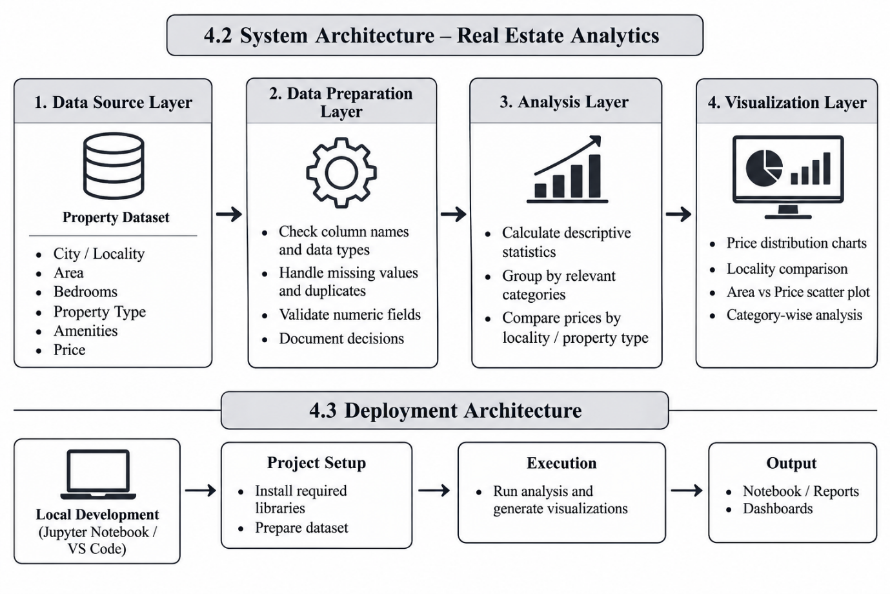

CHAPTER 5

Conclusion and Future Aspects

5.1 Conclusion
EstateIQ AI – Intelligent Real Estate Price Exploration Tool is a data science project designed to explore and analyze property prices across different cities and localities. The project focuses on understanding the relationship between property prices and important factors such as location, property area, number of bedrooms, property type, and available amenities. Through Exploratory Data Analysis (EDA) and data visualization, the system aims to present property-related information in a clear and understandable manner.
The project helps users compare property prices across localities, identify price variations, and understand patterns within the available dataset. It demonstrates how data science techniques can transform raw real estate data into meaningful insights that support informed decision-making. The tool can be useful for homebuyers, students, property researchers, and individuals interested in understanding real estate market trends. The reliability of the insights depends on the quality and completeness of the dataset. Overall, EstateIQ AI provides a foundation for data-driven real estate exploration and analysis.
5.2 Future Aspects
n the future, EstateIQ AI can be enhanced with several advanced features. Machine learning algorithms can be integrated to predict property prices based on location, area, bedrooms, and other relevant features. Real-time property data integration through authorized sources can help users explore updated market information. Interactive map-based visualizations can provide geographical comparisons of property prices across localities.
The system can also be improved by introducing personalized property recommendations based on users’ budgets and preferences, advanced filtering options, and additional interactive dashboards. Expanding the dataset to include more cities and property categories can improve the coverage of the analysis. Finally, deploying the application on a cloud platform and developing a responsive mobile-friendly interface can make EstateIQ AI more accessible and convenient to use.
These enhancements can help transform EstateIQ AI into a comprehensive real estate analysis platform that supports better understanding of property markets and data-driven decisions.

CHAPTER 6
Bibliography

1. Python Software Foundation. Python Documentation. Available at: https://docs.python.org/3/. Accessed October 28, 2026.
2. The pandas Development Team. pandas User Guide. Available at: https://pandas.pydata.org/docs/user_guide/. Accessed October 28, 2026.
pandas 3.0.6 documentation
3. NumPy Developers. NumPy Documentation. Available at: https://numpy.org/doc/. Accessed October 28, 2026.
4. Matplotlib Development Team. Matplotlib Documentation. Available at: https://matplotlib.org/stable/. Accessed October 28, 2026.
5. Plotly Technologies Inc. Plotly Python Graphing Library Documentation. Available at: https://plotly.com/python/. Accessed October 28, 2026.
Plotly+1
6. scikit-learn Developers. scikit-learn User Guide. Available at: https://scikit-learn.org/stable/user_guide.html. Accessed October 28, 2026. This reference is relevant if machine learning or price prediction is implemented or discussed.
GitHub+1
7. Kaggle. Datasets. Available at: https://www.kaggle.com/datasets. Accessed October 28, 2026. If your project uses a Kaggle real estate dataset, replace this general link with the exact dataset page, dataset title, creator, and access date.
8. World Bank. DataBank. Available at: https://databank.worldbank.org/. Accessed October 28, 2026. Use this reference only if you use relevant data from the World Bank.
9. Project Dataset Source. [Insert the exact name and URL of the dataset used in EstateIQ AI]. Accessed [insert date]. This reference is essential because the dataset is the basis for the project's analysis.
10. Course Material. Data Science (24AD3107), Academic Year 2026–2027. Department of Computer Science and Engineering. Use this entry if you refer to course-provided materials in the report.

CHAPTER 7

Appendices

Appendix A: Home Page and Dataset Overview
The Home Page of EstateIQ AI provides a user-friendly interface for exploring real estate prices across different cities and localities. It serves as the main entry point to the application, allowing users to navigate to different sections, view property-related information, and access price analysis features. The Dataset Overview section presents the structure of the property dataset, including attributes such as location, property area, number of bedrooms, property type, and price. These details help users understand the data used for analysis before proceeding to visualization and comparison. Together, these screens illustrate the proposed workflow of EstateIQ AI, from accessing the application to understanding the dataset used for real estate price exploration.

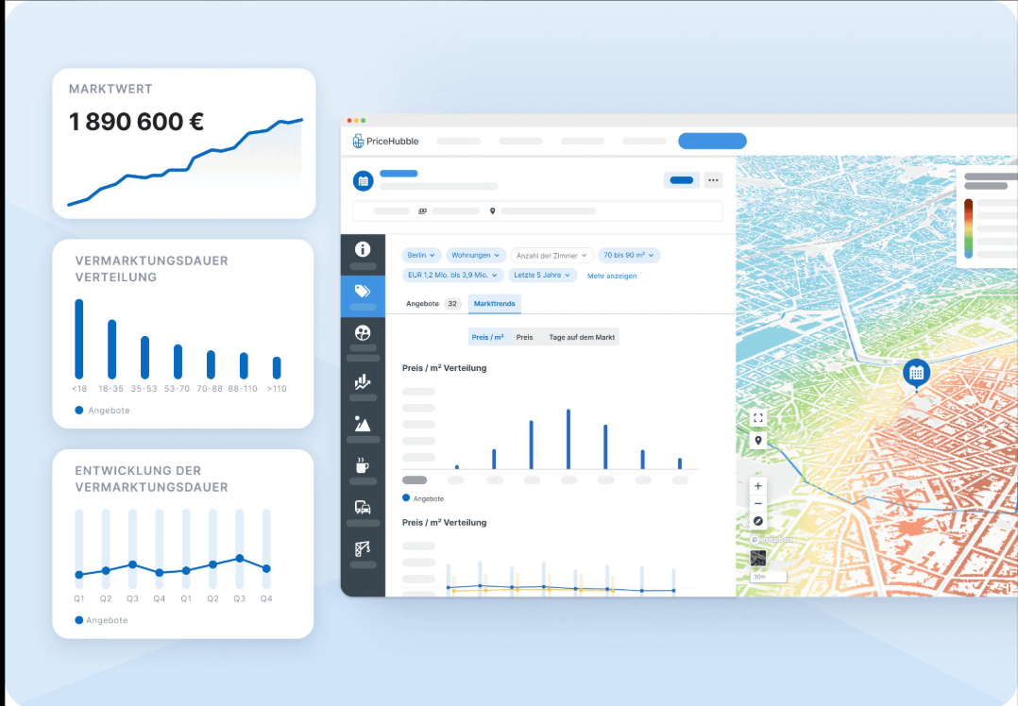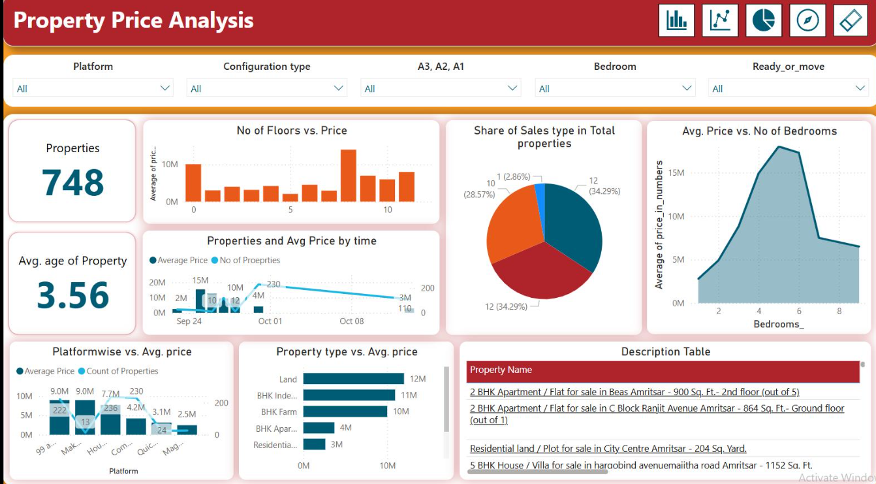
Appendix B:
Property Price Analysis and Visualization Dashboard
The Property Price Analysis dashboard presents an interactive visualization of real estate data to help users understand property price patterns and compare different property characteristics. It displays key indicators, including the total number of properties and the average age of properties, along with charts illustrating the relationship between the number of floors and price, the average price by number of bedrooms, property types, and platform-wise price variations. The dashboard also includes filters such as platform, configuration type, bedroom count, and property readiness status, allowing users to explore specific categories of properties. A description table provides details of individual property listings. These visualizations help users identify price variations, compare property categories, and gain insights into the real estate market through data-driven analysis.



